IOT BASED SMART WATER MANAGEMENT

A project report submitted in partial fulfillment of the

requirements for the degree of B.E Electronics And Communication Engineering

By,

K.SANJAY (513221106320)

Under the supervision of HOD & professor

Department of B.E Electronics And Communication Engineering

PHASE-4: DEVELOPMENT-2 OF SMART WATER MANAGEMENT

Topics:

* ***Introduction of Smart Water Management Systems***
* ***Relevant Survey***
* ***Proposed Method: IoT-Based Smart Water Management System***
* ***Numerical Outcome***
* ***Conclusions***

**Introduction of Smart Water Management Systems:**

★ Smart water management gives a greater understanding of the water system, including flaw detection, preservation, and water management.

★ A comprehensive database of regions with water losses or unlawful connections can be built with the introduction of smart water system technology by public service corporations.

★ Smart water grids can save costs by conserving water and energy while improving the quality of service to consumers. Wireless data transfer allows consumers to assess their water use to reduce water costs in other circumstances.

***Relevant Survey:***

The authors present a survey meant to sum up the current state of the art with regard to IoT-based smart water quality monitoring systems (IoT-WQMS), with a focus on those intended for use in the home, in light of recent developments in IoT that can be applied to the creation of more effective, secure, and inexpensive systems with real-time capabilities. This study looks at common WQM metrics, safe drinking water limits, and smart sensors. It validates contemporary IoT-WQMS with empirical measurements, discussion, and design recommendations. There is little question that this research will contribute to the growing industry of smart homes, workplaces, and cities

By contrast, while they use water, we studied certain investigations that protect water quality and decrease contamination. IoT-SWM system has been proposed to improve the stormwater quality, efficiency ratio, water demand ratio, leakage detection ratio, and non-revenue water ratio. The following section discusses the proposed IoT-SWM system briefly.

***Proposed Method:***

**IoT-Based Smart Water Management Systems:**

The first device measures the water tank’s height and sends real-time information to the cloud using a smart-level device. The GSM module of the smart level sends a signal to another device, a motor-controlled device, which automatically activates and deactivates the motor based on the signal. They activate and deactivate motors when they receive an input signal.

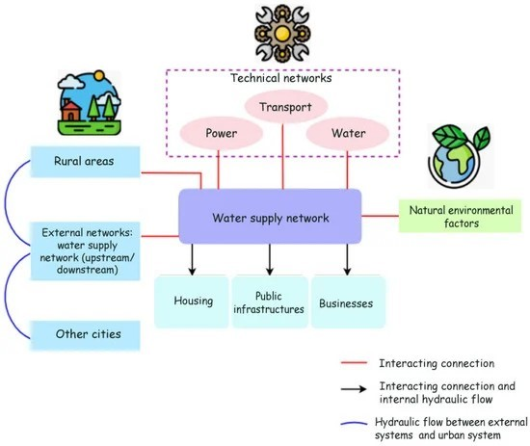

Commercial time 𝑤𝑡𝑘 and water management fee , as well as the link between the 𝜌 actual time 𝑤𝑚𝑖 and actual price 𝑤𝑡𝑖 is defined as

𝑤𝑡𝑘 𝜌= ⎝∑ ,𝑖 𝑚𝑁𝐺𝑖 𝑚𝑉𝑡𝑢𝑚𝑖 𝑒 𝑤𝑚𝑖 𝑤𝑡𝑖, * ( , )⎞

As shown in Equation (1), traders 𝐺𝑖 𝑚, , current traditional finance 𝑉𝑡 claims are impacted by 𝑢𝑚𝑖 reporting, which they believe is illogical. The major service provider’s profit function 𝑈𝑧 has not been affected by strategic forecasting 𝑤, which is given as, 𝑈𝑧 𝑤 𝜔𝑟𝑖 𝑠𝑖 𝑠 𝑥 𝑥𝑖= + − + ( − )2

After activating the mode, the consumer will not utilize the tank throughout the inspection. An application will record an inspection’s beginning and ending times for use in subsequent computations; if no leakage is detected, the inspection will end by itself after 6 h.

***Numerical Outcome:***

Internet of Things-based smart water systems can assist prevent these scenarios from occurring and repair the harm that has already been done due to the careless use of water resources. From a freshwater reservoir to the collection and recycling of wastewater, smart water technology makes the entire water supply chain more transparent and controllable.

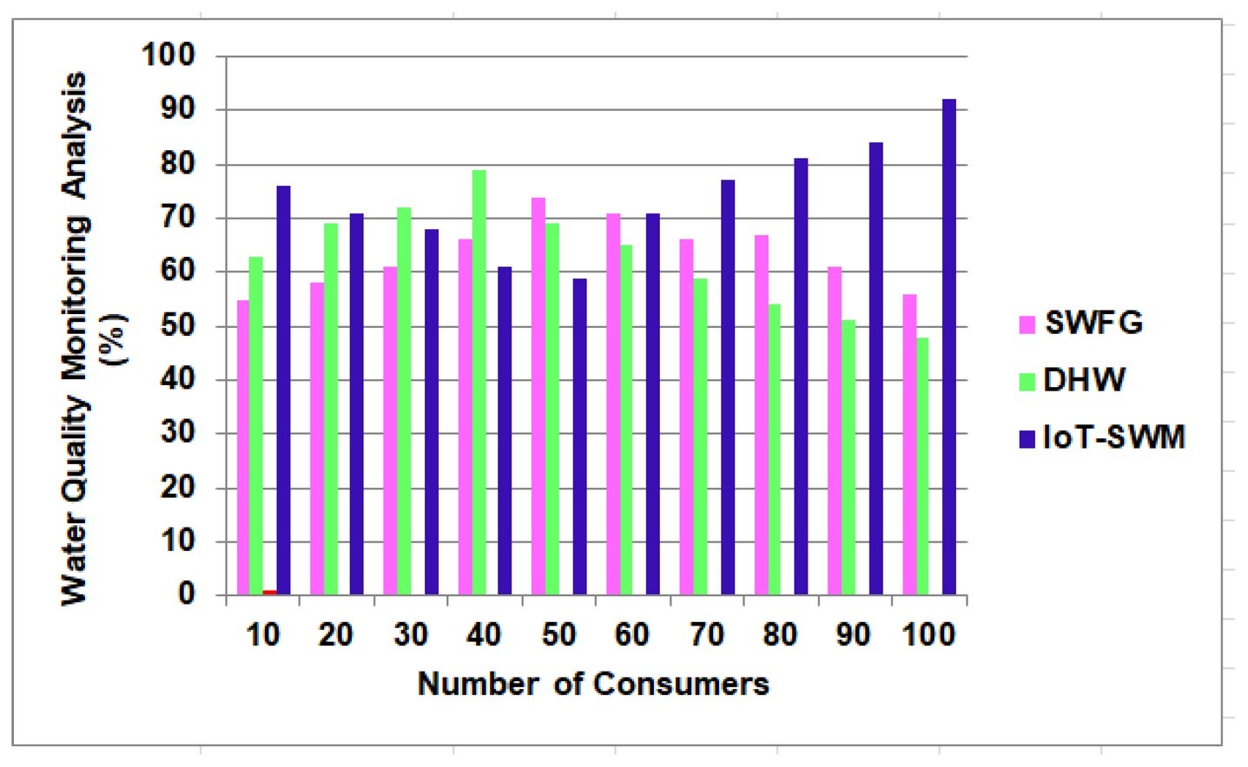

This water meets all the requirements for safe consumption, including pH and electrical conductivity. As a result, the study’s findings suggest installing a basic filtration system to catch roof sediments before they reach the storage tank and enhancing stormwater quality analysis by 98.7%.

***Table 1.*** Analysis of stormwater quality.

|  |  |  |  |
| --- | --- | --- | --- |
| **Number of Consumers** | **SWFG** | **DHW** | **IoT-SWM** |
| 10 | 52 | 65 | 78.5 |
| 20 | 54.5 | 67 | 84 |
| 30 | 55 | 64 | 79 |
| 40 | 58 | 70.8 | 81 |
| 50 | 50.1 | 61.3 | 94 |
| 60 | 56 | 63.7 | 85.7 |
| 70 | 59 | 66 | 97.1 |
| 80 | 57 | 68.4 | 87 |
| 90 | 53 | 69 | 92 |
| 100 | 52.8 | 62 | 98.7 |

In addition, it has been proposed as future work to develop an Internet of Things (IoT)-based architecture for a smart water management system that incorporates all these crucial features and uses IoT-based predictions to boost its efficacy.

***Table 2.*** Efficiency ratio.

|  |  |  |  |
| --- | --- | --- | --- |
| **Number of Consumers** | **SWFG** | **DHW** | **IoT-SWM** |
| 10 | 58 | 60 | 75 |
| 20 | 45 | 73 | 78.9 |
| 30 | 52.4 | 66 | 90 |
| 40 | 60.8 | 75.9 | 87 |
| 50 | 59 | 77 | 92 |
| 60 | 65 | 69 | 88 |
| 70 | 55 | 76 | 91 |
| 80 | 50.9 | 71 | 87 |
| 90 | 52 | 77 | 80 |
| 100 | 56 | 60.8 | 95.1 |

This is due to various factors, including increased agricultural and industrial use, residential use, and concealed virtual water. The suggested approach enhances water demand analysis by 93.6 % compared to the previous methods.

***Table 3.*** Analyzing water demand ratio.

|  |  |  |  |
| --- | --- | --- | --- |
| **Number of Consumers** | **SWFG** | **DHW** | **IoT-SWM** |
| 10 | 55 | 70 | 74.5 |
| 20 | 43.5 | 63 | 78 |
| 30 | 59 | 76 | 84 |
| 40 | 60 | 65 | 89 |
| 50 | 52 | 78 | 79 |
| 60 | 55 | 69 | 85 |
| 70 | 58.9 | 77 | 91 |
| 80 | 51 | 71 | 94 |
| 90 | 59 | 73.8 | 87 |
| 100 | 53 | 65 | 93.6 |

Internet of Things (IoT) can be integrated into a water management system to forecast the amount of water needed by a smart house or campus at various times of the day and throughout the year. The same method can be used to meet the water needs of the campus’s numerous structures. Similarly, studying and anticipating how things like a wet season may affect water quality is possible.

***Table 4.*** Leakage detection ratio.

|  |  |  |  |
| --- | --- | --- | --- |
| **Number of Consumers** | **SWFG** | **DHW** | **IoT-SWM** |
| 10 | 46.3 | 65.9 | 76.8 |
| 20 | 55 | 71 | 87 |
| 30 | 47 | 73 | 82.6 |
| 40 | 49.9 | 65 | 90.2 |
| 50 | 53 | 60.9 | 79 |
| 60 | 57 | 64 | 86 |
| 70 | 45.1 | 72 | 94 |
| 80 | 51 | 71 | 84 |
| 90 | 58 | 78 | 86.9 |
| 100 | 60 | 79.7 | 97.5 |

NRW can originate from business losses due to under-registration of client meters, data processing problems, illicit connections, and theft. Unbillable authorized consumption, such as water used by utilities for operations, water used in firefighting, and water provided for free to specific consumer groups, is another reason for NRW.

***Table 5.*** Analyzing non-revenue water ratio.

|  |  |  |  |  |  |  |
| --- | --- | --- | --- | --- | --- | --- |
| **Number of Consumers** | **SWFG** | | **DHW** | | **IoT-SWM** | |
| 10 | 61 | | 76 | | 89 | |
| 20 | 75 | | 82 | | 84 | |
| 30 | 65 | | 88 | | 90.4 | |
| 40 | 73 | | 79 | | 88 | |
| 50 | 64 | | 75 | | 82 | |
| 60 | 70 | | 83 | | 95 | |
| 70 | 68 | | 78 | | 89 | |
| 80 | 60 | | 86 | | 90 | |
| 90 | 71 | | 89.4 | | 91 | |
| 100 | | 54 | | 81 | | 98.4 |

***Conclusions:***

The water sector has been grappling with creating an efficient and longlasting water system. It is included in the IoT-SWM. People intend to broadcast more data to the cloud and analyze it further to construct some algorithm to determine the tank’s lifespan and the proper aspects of leaking. Procedures and actions are determined depending on the threshold, capital cost, and the accessibility of equipment and materials. Even though statistically minimal water savings can be achieved using inline flow restrictors, they can be much more cost-effective than waterefficient taps in certain situations. If they have been installed as part of normal maintenance visits, the expenses would be lower.